The laboratory work 9
The tic-tac-toe game realization 2

Looking at a Brief Example
To apply this, let's take an example from near the end of a game, where it is my turn. I am X. My goal here, obviously, is to maximize my end game score.
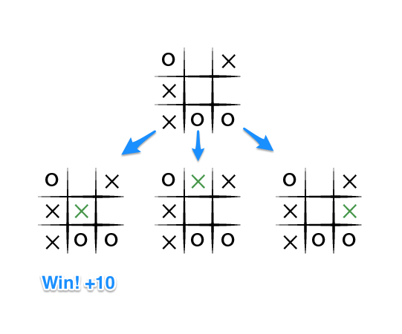
If the top of this image represents the state of the game I see when it is my turn, then I have some choices to make, there are three places I can play, one of which clearly results in me wining and earning the 10 points. If I don't make that move, O could very easily win. And I don't want O to win, so my goal here, as the first player, should be to pick the maximum scoring move.

At this step we need to build the template of the game. We play with a computer, but we still need to add THE MACHINE MOVE using MINIMAX function.
The code for building the whole board and making steps in the game
#include "stdafx.h"
#include <iostream>
#include <iterator>
#include <string>
#include "MiniMax.h"

using namespace std;

void print_board(int board[9])
{
int i, j;
for (i = 0; i < 3; i++)
{
cout << " ";
for (j = 0; j < 3; j++)
{
if (board[i * 3 + j] == 1)
cout << " X ";
else if (board[i * 3 + j] == -1)
cout << " O ";
else if (board[i * 3 + j] == 0)
cout << " ";
if (j != 2)
cout << " | ";
}
if (i != 2)
cout << "\n----------------" << endl;
else
cout << " ";
}
cout << "\n" << endl;
}

void print_instructions()
{
cout << "\nThe board is laid out as folows:\n";
cout << " 1 | 2 | 3" << endl;
cout << "-----------------" << endl;
cout << " 4 | 5 | 6" << endl;
cout << "-----------------" << endl;
cout << " 7 | 8 | 9" << endl;
}

char select_starter()
{
cout << "\nWeclome to Tic Tac Toe" << endl;
cout << "Would you like to be the 'X' or the 'O'?" << endl;
bool valid_user = false;
char user = ' ';
while (!valid_user)
{
cout << "Type X or O: ";
cin >> user;
if (user == 'X' || user == 'O')
{
valid_user = true;
cout << "Great. You are " << user << endl;
if (user == 'X')
cout << "You will go first" << endl;
else
{
cout << "The machine will go first" << endl;
cout << "Good luck";
}
}
}
return user;
}

int get_input(int board[9], char turn)
{
bool valid = false;
int response;
int move;
int arr[9] = { 1,2,3,4,5,6,7,8,9 };
while (!valid)
{
cout << "\nWhere would you like to make your move (You are "<< turn << ")? Pick 1-9" << endl;
cin >> response;
bool exists = find(begin(arr), end(arr), response);
if (exists)
{
move = response - 1;
if (board[move] == 0)
return move;
else
{
cout << "That position has already been taken " << endl;
}
}
else
cout << "That is not a valid move. Try again!" << endl;
}
}

int machine_move(int board[9], char my_symbol)
{
bool valid_move = false;
int move;
int arr[9] = { 0, 1, 2, 3, 4, 5, 6, 7, 8 };
while (!valid_move)
{
move = mymove(board, my_symbol);
bool exists = find(begin(arr), end(arr), move);
if (exists)
{
if (board[move] == 0)
return move;
else
{
cout << "That position has already been taken " << endl;
return 0;
}
}
else
cout << "That is not a valid move! Please try again! " << endl;
}
}

string check_win(int board[9])
{
int i, j;
int threes[8][3] = { {1,2,3},{4,5,6},{7,8,9},{1,4,7},{2,5,8},{3,6,9},{1,5,9},{3,5,7} };
int total = 0;
for (i = 0; i < 8; i++)
{
total = 0;
for (j = 0; j < 3; j++)
{
total += board[threes[i][j] - 1];
}
if (total == -3)
return "O";
else if (total == 3)
return "X";
}
return "No winner";
}

int get_move(int board[9], char turn, char user)
{
if (turn == user)
return get_input(board, turn);
else
return machine_move(board, turn);
}

int main()
{
int board[9] = { 0,0,0,0,0,0,0,0,0 };
print_instructions();
char user_symbol = select_starter();
bool win = false;
int move = 0;
char turn;
int target;
int turn_value;
string winner;
while (!win)
{
move = move + 1;
cout << "\nThe state of the game is as follows:" << endl;
print_board(board);
if (move % 2 == 1)
{
turn = 'X';
target = 1;
}
else
{
turn = 'O';
target = -1;
}
turn_value = get_move(board, turn, user_symbol);
board[turn_value] = target;
cout << "\nChecking for winner ";
winner = check_win(board);
if (winner != "No winner")
{
cout << "The winner is " << winner << endl;
print_board(board);
win = true;
}
else if (move >= 9)
{
cout << "The game is a draw" << endl;
print_board(board);
win = true;
}
else {
cout << "No winner yet" << endl;
}
}
return 0;
}

